Using AI agent to Query X++ Metadata in D365FO
Recently, I came across an interesting task and want to share the approach I used, as it may be helpful in other areas.
Task: Consultants want to export all D365FO menu elements to an Excel file, including menu items, linked forms, labels, etc.
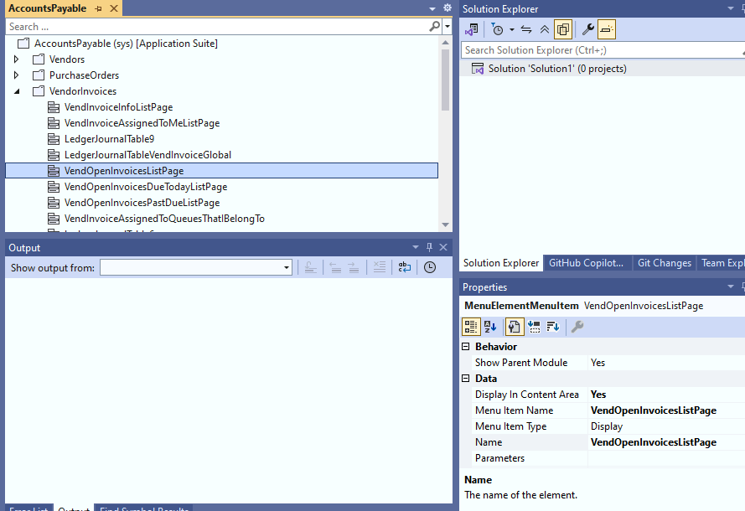
After discussing the export requirements, we defined the following logic:
- * Process all menus and menu extensions for the whole application.
- * For every menu element, find the relevant menu item.
- * Get the menu item properties and label.
- * For the label: find the relevant label in the EN-AU language.
- * Save all results to an Excel file.
What I did
First, I described in detail how to find each element. This took some time, but the description can be reused for future tasks (the file is here: https://github.com/TrudAX/TRUDScripts/blob/master/Documents/AIPrompts/claude_ReadAllMenuItems.md )
Then, I installed **Claude Code** and gave Claude the task: *"Read claude_ReadAllMenuItems.md, write a Python script, and execute it on the local VM."*
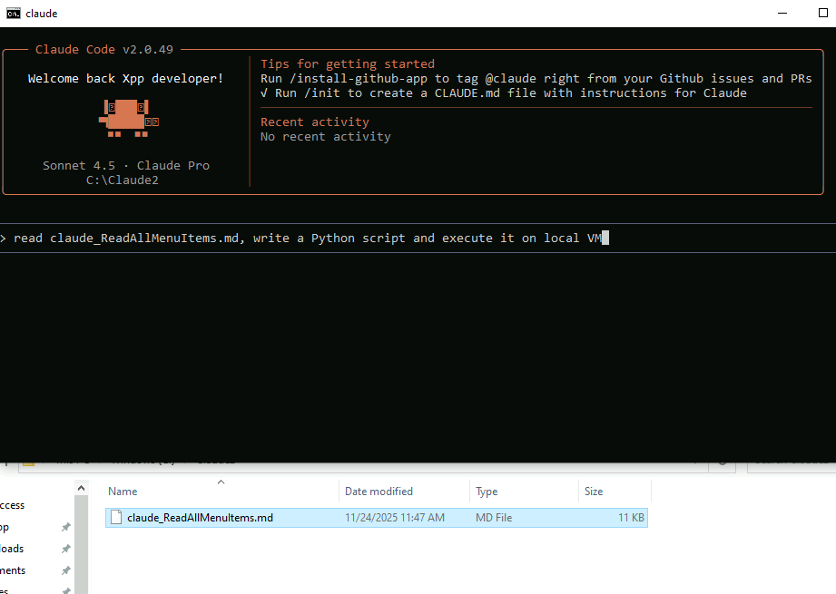

After a 5-minute wait and a couple of confirmations, I got a file with 6,000 lines containing the required data.
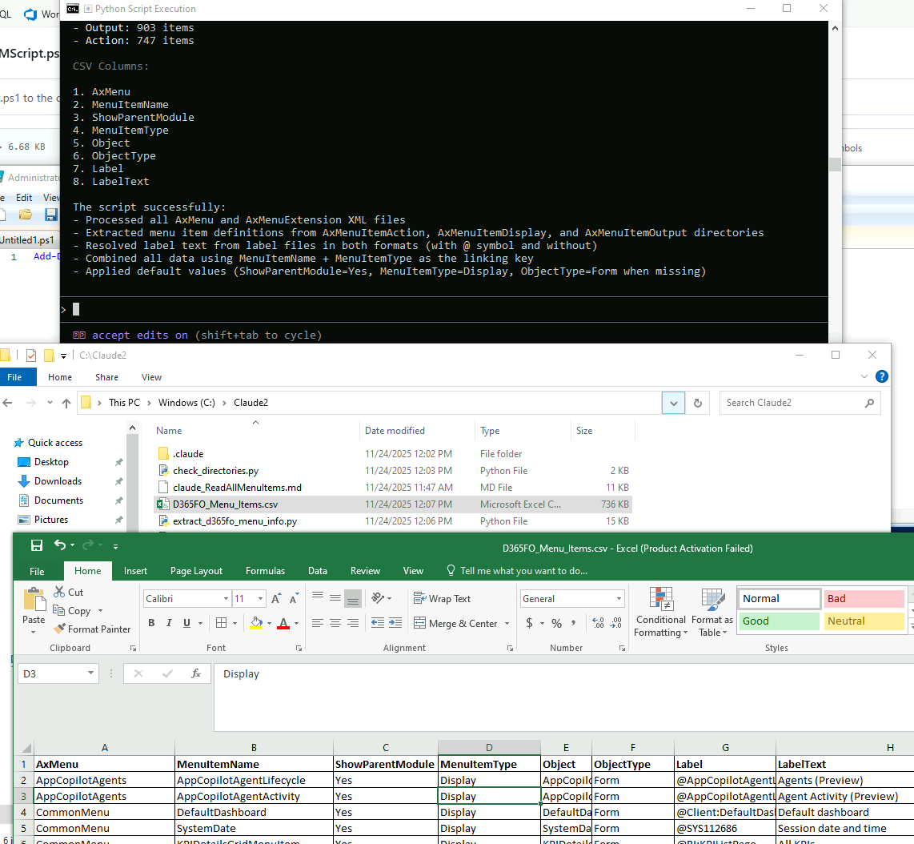

**Comparison with Other Agents** I attempted this with other agents, but the results varied: * **Gemini:** The current version failed to complete the task, generating a file with only a few lines. Hopefully, the upcoming 3.0 model (currently on waitlist) will perform better. * **ChatGPT (Codex):** The agent integration does not currently support Windows officially.

I also checked other current agents:
- Old Gemini with 2.5 for some reason failed this, it generated the file only with a couple of lines, they have a wait list for a new model 3.0, maybe it will be better
- And Codex(agent from ChatGPT) don’t officially support Windows
Please note that using Claude Code requires either an API payment (this specific task cost a few dollars) or a $20 monthly subscription (which has session/weekly limits).
**Conclusion**
Overall, the results were excellent—Claude handled the task in one shot. If you haven't tried Claude yet, I recommend giving it a chance. If you have solved similar tasks using AI, feel free to share your experience!

